APPLYING FOR A TEMPORARY LICENSE

Go to: https://www.motorsportreg.com

Create a new account if you don’t have one already.:


Fill in your information:
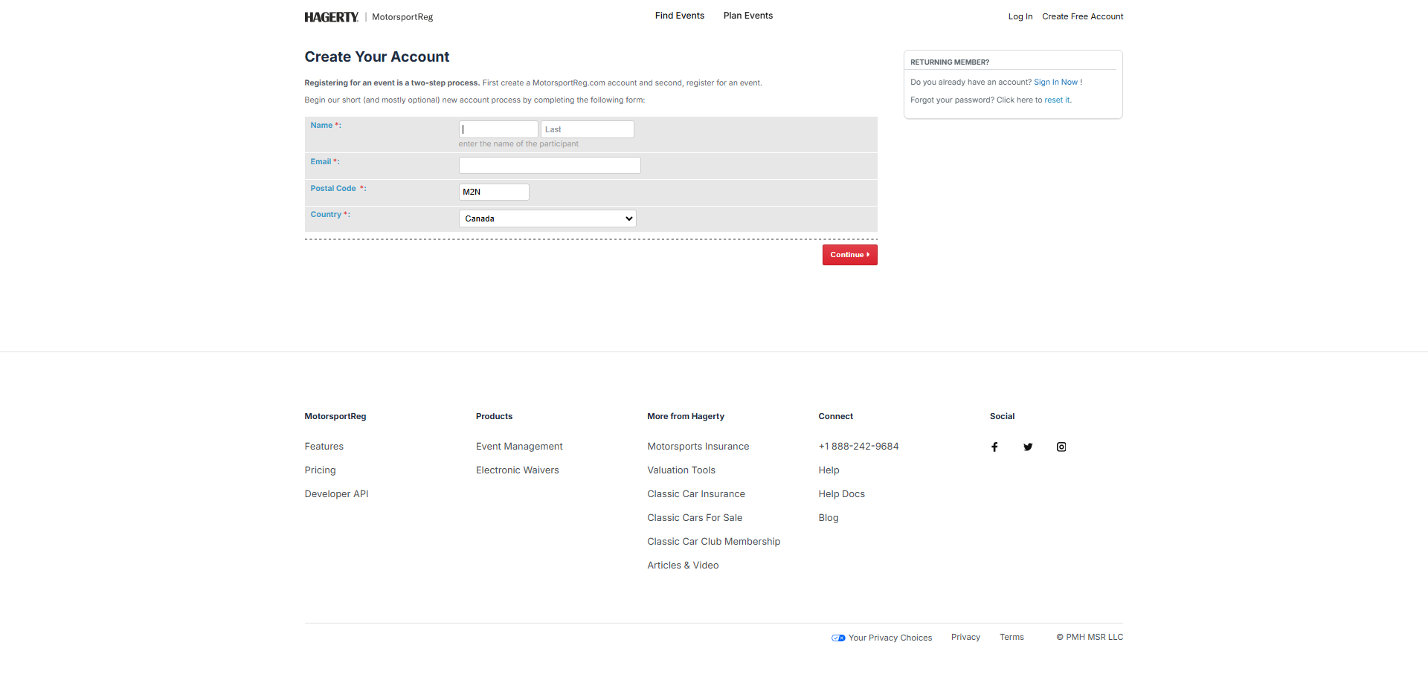

Find CASC-OR Events: Click “Find Events”
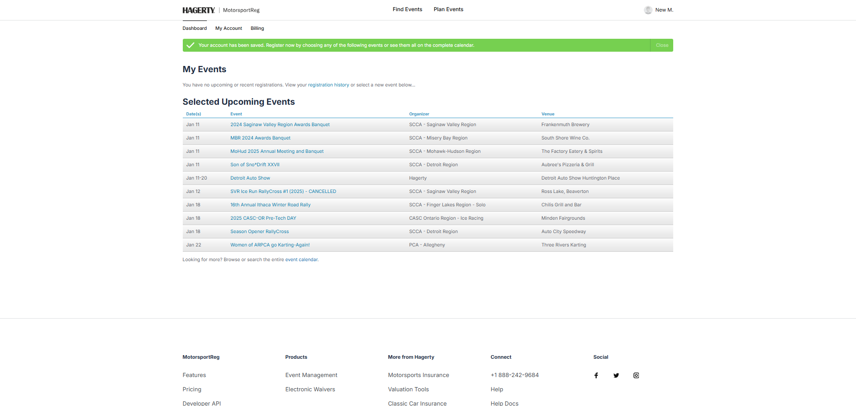

Find the events by typing in the search box: “CASC Ice” and click Search
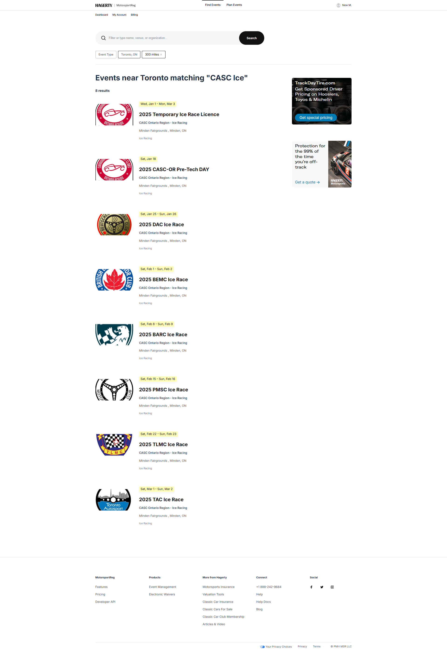
Click “2025 Temporary Ice Race Licence”.

